Project Design Phase-II Data Flow Diagram & User Stories

|  |  |
| --- | --- |
| Date | 16 October 2022 |
| Project Name | Project - Real time river water monitoring and  control system |
| Maximum Marks | 4 Marks |

# Data Flow Diagrams:

A Data Flow Diagram (DFD) is a traditional visual representation of the information flows within a system. A neat and clear DFD can depict the right amount of the system requirement graphically. It shows how data enters and leaves the system, what changes the information, and where data is stored.

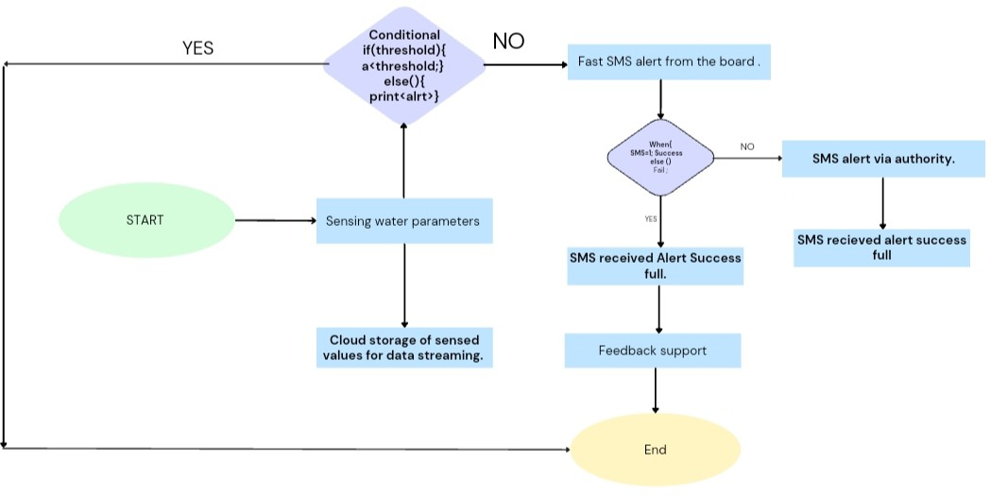

# User Stories

Use the below template to list all the user stories for the product.

|  |  |  |  |  |  |  |
| --- | --- | --- | --- | --- | --- | --- |
| User Type | Functional  Requirement (Epic) | User Story  Number | User Story / Task | Acceptance criteria | Priority | Release |
| Customer (Mobile  user) | Registration | USN-1 | As a user, I can register for the application by  entering my email, password, and confirming my password. | I can access my account /  dashboard | High | Sprint-1 |
|  |  | USN-2 | As a user, I will receive confirmation email once I  have registered for the application | I can receive confirmation  email & click confirm | High | Sprint-2 |
|  |  | USN-3 | As a user, I can register for the application  through Facebook | I can register & access the  dashboard with Facebook Login | High | Sprint-1 |
|  |  | USN-4 | As a user, I can register for the application  through Gmail | I can register through mail | Medium | Sprint-2 |
|  | Login | USN-5 | As a user, I can log into the application by  entering email & password | I can receive login credentials | High | Sprint-1 |
|  | interface | USN-6 | As a User, I prefer an comparable user interface(UI),that can provide quick switch speed and is user friendly. | I can access it with ease | Medium | Sprint-1 |
| Customer (Web  user) | Dashboard | WUSN-1 | As a Web user, it is necessary for me to infer the  quality of water by personally assure the physical and chemical parameter of water.for that i need dynamic access to sensing parameters and WSN values such as pH ,dust, turbidity,temperature . | I can be abled to observe the  values for quality of water | High | Sprint-1 |
| Customer Care  Executive | View manner | CCE-1 | As a customer care, I can need data visualization. | I can understand easily via  visualization. | High | Sprint-1 |
|  | taste | CCE-2 | As a customer care,an DBMS linked to this  system is preferable for infering about the quality of water(presense of hardness and other salts) | I can easily know the  presence of hardness and salts. | High | Sprint-1 |

|  |  |  |  |  |  |  |
| --- | --- | --- | --- | --- | --- | --- |
| User Type | Functional  Requirement (Epic) | User Story  Number | User Story / Task | Acceptance criteria | Priority | Release |
|  | colour visibility | CCE-3 | As a customer care, it's important for me to  analyze the turbidity and shade of water(colour) | I can know the colour of  water which leads to result about condition of water. | High | Sprint-1 |
| Administrator | tolerance | ADMIN-1 | An administrative block must take care of the  system applications. | Time continuous monitoring  through an administrator | High | Sprint-2 |